Infection Prevention and Control

Information Leaflet for Parents

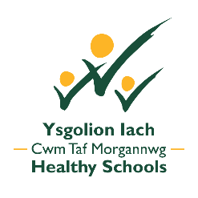
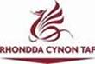

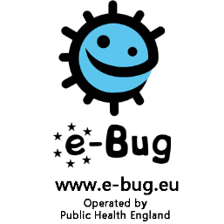

The purpose of this leaflet is to provide you with information on our Infection Prevention and Control Policy and education programme in school.

Infectious diseases such as respiratory (coughs and colds) and gastrointestinal illnesses (diarrhoea and vomiting) are common in children. These illnesses can cause a lot of absenteeism in children attending school.

At Penyrenglyn Community Primary School we aim to educate our pupils on microbes, the spread, treatment and prevention of infection and antibiotic use.

If we can reduce the spread of infection in children and young people by educating them on these topics, we can reduce infections and reduce antibiotic use and subsequently reduce antibiotic resistance.

Antibiotic resistance is one of the biggest threats facing us today. Without effective antibiotics many routine treatments will become increasingly dangerous.

As a school we follow the *All Wales Infection Prevention and Control Guidance for Educational Settings (2017) and our school’s Hygiene Policy and everyday practice is centred on this guidance. We are committed to the health, safety and well-being of the whole school and wider community. It is therefore important that clear effective guidelines for the prevention and control of infection are in place and implemented within our school.
*(Public Health Wales (2017) All Wales Infection Prevention and Control Guidance for Educational Settings. Public Health Wales NHS Trust)

Infection Prevention and Control in the Curriculum:

We aim to deliver consistent and accurate hygiene messages through the formal and informal curriculum to empower pupils to identify, develop and implement good hygiene practices and to develop a responsible attitude towards keeping their bodies safe and healthy. Throughout Key Stage 2 pupils will receive a series of fun and interactive lessons using the e-Bug resource focusing on the following topics:
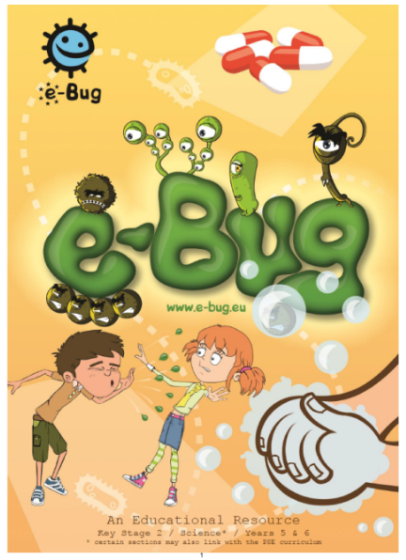
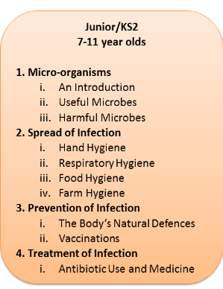

Pupils will take part in these lessons in Key Stage 2. If you wish to see the lessons in more detail, a copy of our school’s policy or view any of the resources please visit the eBug website.

How can you help to reinforce these important messages at home?

Hand Hygiene: 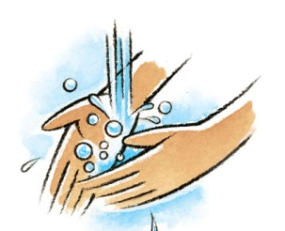
Hand washing is one of the most important ways of controlling the spread of infections, especially those that cause diarrhoea, vomiting and respiratory disease. When we touch other people, animals, body fluids, contaminated surfaces or food for example, we pick up germs on our hands. These germs can then pass into our bodies and can cause illness, or spread to other things that we touch. This is why we need to wash our hands regularly throughout the day and especially:
Before:
- Preparing and serving food or drink
- Eating and drinking

After:
- Using the toilet
- Coughing, sneezing or blowing / wiping your nose
- Touching rubbish / waste bins
- Handling raw foods, particularly meat, poultry or fish
- Changing nappies
- Contact with body fluids such as vomit
- Handling pets or farm animals
- Helping / playing in the garden
The recommended hand washing method is to use liquid soap, warm water, and paper towels or hand drier. It is also really important to remember to dry hands thoroughly to minimise the spread of infection and use a paper towel (if available) after handwashing, as a further barrier when turning off taps.
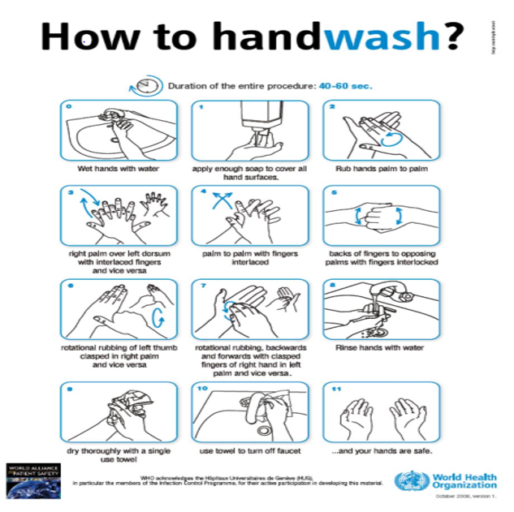

Coughing and Sneezing:
Coughing and sneezing easily spread infections. When coughing or sneezing individuals should be encouraged to cover their nose and mouth with a tissue. Tissues should be disposed of appropriately and hands washed after using or disposing of tissues. Spitting should be discouraged. Remember to Catch It, Bin It, Kill It!
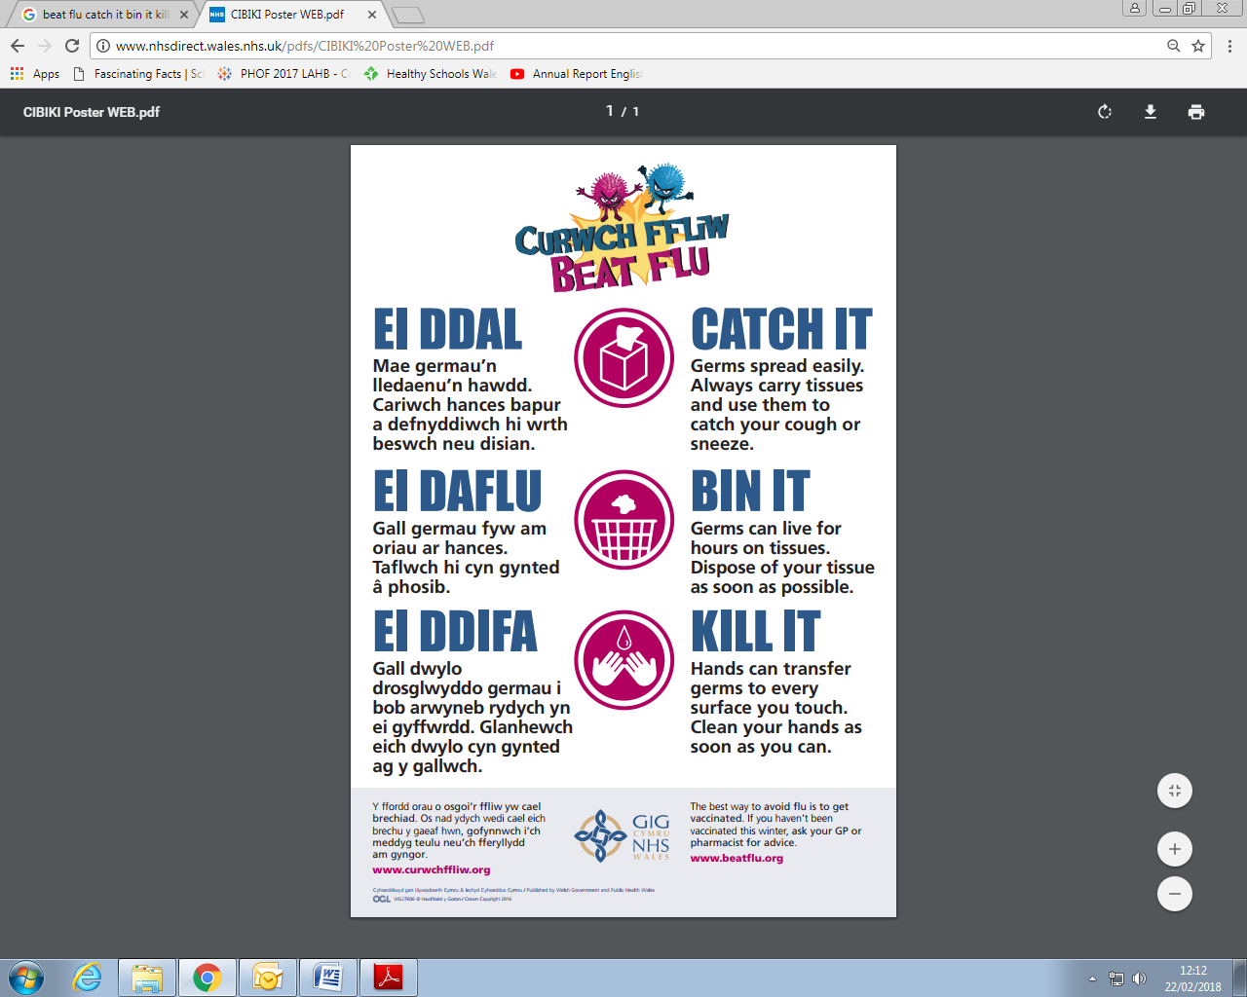

Farm Visits:
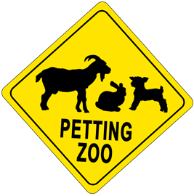

Whilst it is popular to visit farms and zoos, there are a number of infections that can be passed on to people from infected animals. Serious outbreaks have been associated with visits to farms and zoos.

Even farm animals that look clean and healthy will carry a range of germs such as campylobacter, salmonella and cryptosporidium which can be passed on and cause infection in humans. They can also carry the bacteria Escherichia coli O157 (E. coli O157), which is very infectious and can cause extremely severe or life-threatening illness.

Remember to wash and dry hands thoroughly after visiting and petting/feeding animals.

Cases of infectious disease:

If your child has diarrhoea and/or sickness it is essential that they do not attend school. Please keep them at home until diarrhoea and/or sickness has stopped for at least 48 hours.

Inform us immediately if your child has an infectious disease or illness. This will enable the school to undertake any action if necessary and to provide you with further information on how long your child should stay off school for.

Vulnerable/at risk children:

If your child is particularly at risk of becoming ill from an infectious disease, either because they have a medical condition which affects their immunity or are not vaccinated (this includes if they have not had a full course of a vaccine), please let us know. This is important so we can tell you about any infectious diseases within the school that could put your child at risk.

Vaccinations:

Please ensure your child is up to date with recommended vaccinations. The routine immunisation schedule for Wales outlines the vaccinations your child should have been offered. For the most up-to-date immunisation advice see the NHS Direct Wales website www.nhsdirect.wales.nhs.uk or the school health service can advise on the latest national immunisation schedule.

If you are concerned that your child has not received all of their vaccinations, please speak to your doctor (GP) as soon as possible.

More Information:
The Facts About Head Lice:
https://gov.wales/docs/phhs/publications/100701headliceen.pdf
Alternatively, you can speak to your School Nurse or Health Visitor
Making Lunchboxes Healthier and Keeping Them Cool:
https://gov.wales/docs/change4life/publications/151111lunchboxesen.pdf
Thanks are extended to the Health Protection Team in Public Health Wales and the Environmental Health Departments in both Rhondda Cynon Taf and Merthyr Tydfil for their feedback in the creation of this leaflet. Thanks also, to both Local Authority Educational Departments.



