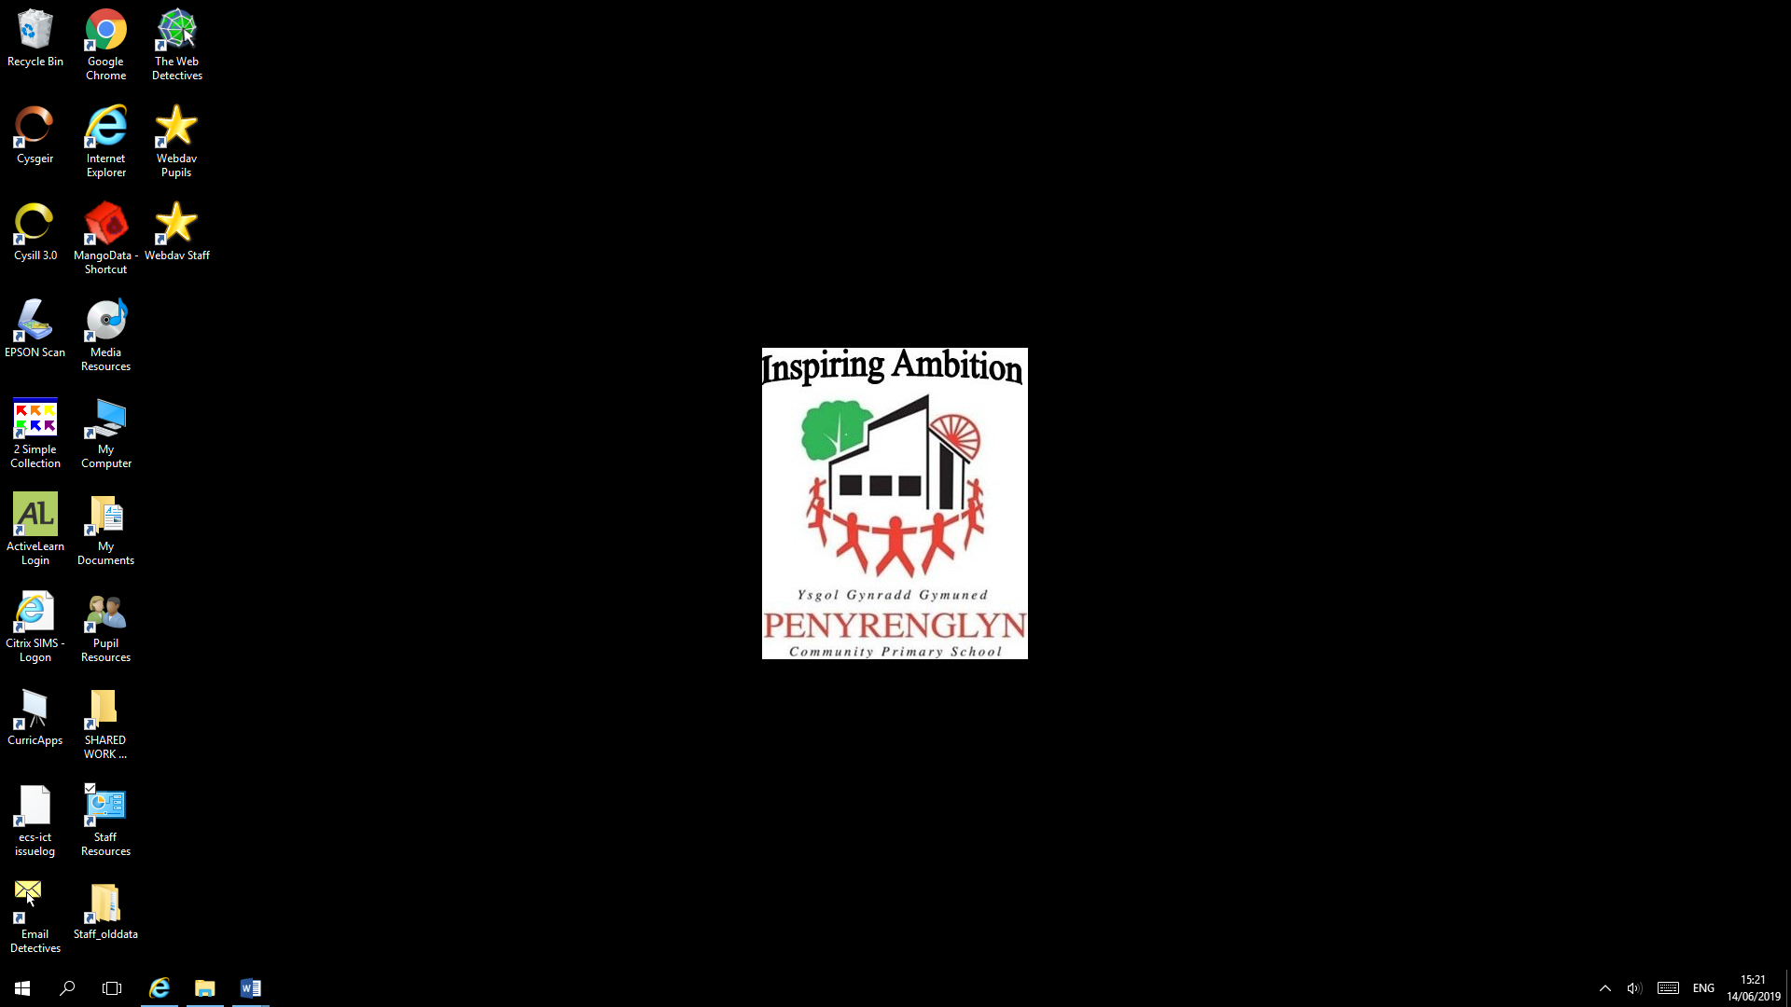

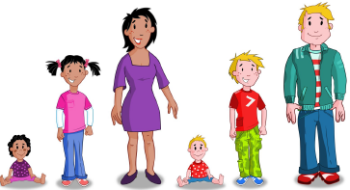

Personal Development and Relationships

Information booklet for parents

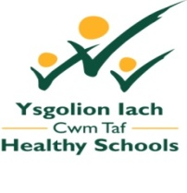
The purpose of this leaflet is to provide you with information on our Personal Development and Relationships programme.
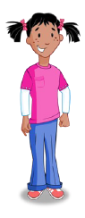
Our Jigsaw scheme of work, including the ‘Relationships’ and ‘Changing Me’ modules, has been developed to support the delivery of high quality healthy relationships education. The knowledge and skills pupils in Foundation Phase and Key Stage 2 will gain from this series of lessons will help to build their resilience, confidence and self-esteem to empower them to develop and maintain healthy relationships as they move through childhood into adolescence.
Personal Development and Relationships education is a term used to describe the range of learning experiences and support that schools provide for pupils to develop safe, respectful personal relationships. This includes taking responsibility for their behaviour in their personal relationships, how to recognise inappropriate behaviour, keep themselves safe and the changes that will happen to their body as they grow up.
Our Personal Development and Relationships programme and teaching have been informed by;
- Welsh Government Sex and Relationships Education in Schools guidance (2010)
- The Personal and Social Education Framework for 7-19-year-olds in Wales
- Foundation Phase, Personal and Social Development, Well-being and Cultural Diversity area of learning

We will be using the Jigsaw scheme of work, which has been agreed by our Healthy Schools Liaison Officer in Cwm Taf to deliver high quality personal development and relationships education.


Pupils will learn about Personal Development and Relationships through:

- The ‘Relationships’ and ‘Changing Me’ modules of the Jigsaw scheme of work and teaching resources
- The Gwynedd Healthy School Scheme ‘Growing Up/ Tyfu i Fyny’ teaching resources
- The ‘Sense- Growing Up and Keeping Safe’ CD
- The NSPCC ‘PANTS Underwear Rule’, resources and Pantosaurus cartoon
- School Beat website
- Circle time activities. This is when we might talk about growing up while sitting in a circle with other classmates
- Sessions with the School Nurse
- Story books

Jigsaw Pieces of Learning for Nursery and Reception

- My body
- Respecting my body
- Growing up
- Growth and change
- Fun and fears

Jigsaw Pieces of Learning for Year 1

- Life cycles
- Changing me
- My changing body
- Boys’ and girls’ bodies
- Learning and growing
- Coping with changes
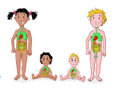
Jigsaw Pieces of Learning for Year 2

- Life cycles in nature
- Growing from young to old
- The changing me
- Boys’ and girls’ bodies
- Assertiveness
- Looking ahead

Jigsaw Pieces of Learning for Year 3

- How babies grow
- Babies
- Outside body changes
- Inside body changes
- Family stereotypes
- Looking ahead
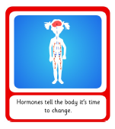
Jigsaw Pieces of Learning for Year 4

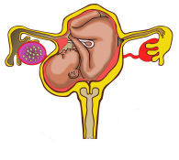
- Unique me
- Having a baby
- Girls and puberty
- Circles of change
- Accepting change
- Looking ahead

Jigsaw Pieces of Learning for Year 5

- Self and body image
- Puberty for girls
- Puberty for boys
- Conception
- Looking ahead
- Looking ahead to year 6

Jigsaw Pieces of Learning for Year 6

- My self-image
- Puberty
- Girl talk / boy talk
- Babies – conception to birth
- Attraction
- Transition to secondary school

If you wish to see the lessons in more detail, a copy of our school’s policy or view any of the resources please ask your child’s class teacher or visit the school website.

Useful links for parents:
Sex and Relationships Education in Schools (Welsh Government, 2010) http://learning.gov.wales/docs/learningwales/publications/130425-sex-and-relationships-education-in-schools-en.pdf
For a guide to talk to your child about the NSPCC Underwear Rule please follow this link: https://www.nspcc.org.uk/globalassets/documents/advice-and-info/underwear-rule-guide-for-parents.pdf
Family Panning Association, Parental Information Leaflets: How to talk to your child about Sex and Relationships Education http://www.publichealthnetwork.cymru/files/2614/4359/8957/Factsheet1_HowToTalkChildrenAboutSRE.pdf

SchoolBeat.org is a bilingual site from the All-Wales School Liaison Core Programme, providing information and resources for teachers, pupils and parents to follow up on the lessons provided to primary and secondary school children by our School Community Police Officers. The website focuses on the three main themes of the Programme: drug and substance misuse, social behaviour and community and personal safety
https://www.schoolbeat.org/en/pupils/

This leaflet has been designed with kind permission from the Gwynedd Healthy Schools Scheme.

