Outline of ‘Healthy Me’ modules from nursery to year 6, including suggested vocabulary

Jigsaw Scheme of Work

Who does the scheme cater for?
Nursery and Reception, Year 1, Year 2, Year 3, Year 4, Year 5, Year 6

What does the scheme consist of?
There are 6 modules for each year group:

Being Me in My World
Celebrating Difference
Dreams and Goals
Healthy Me (SME)
Relationships
Changing Me

Nursery / Reception
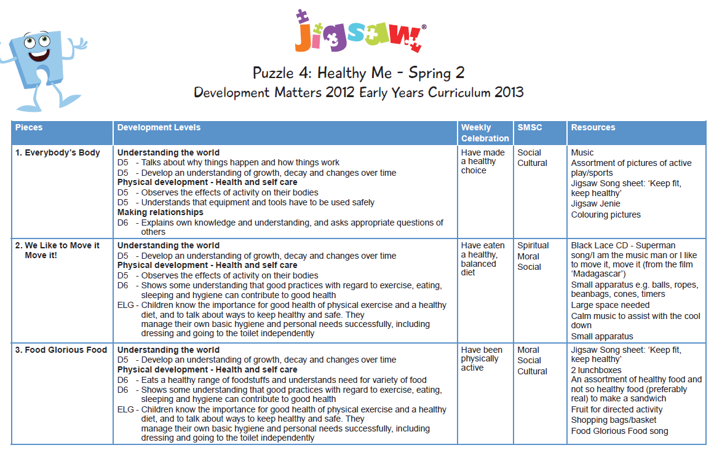

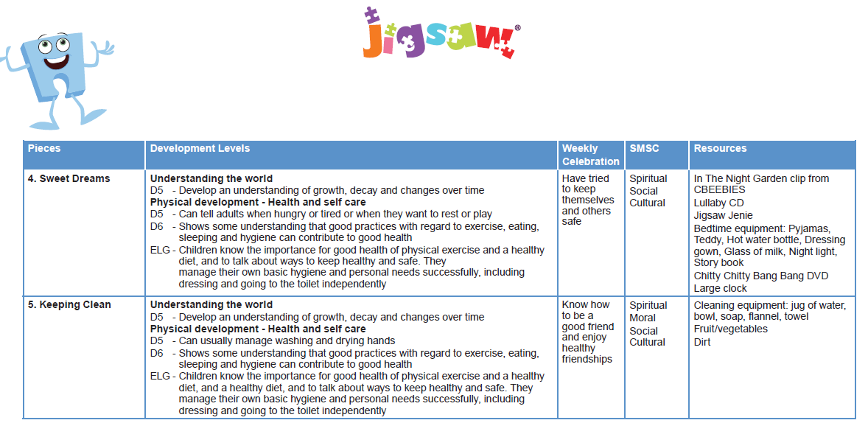
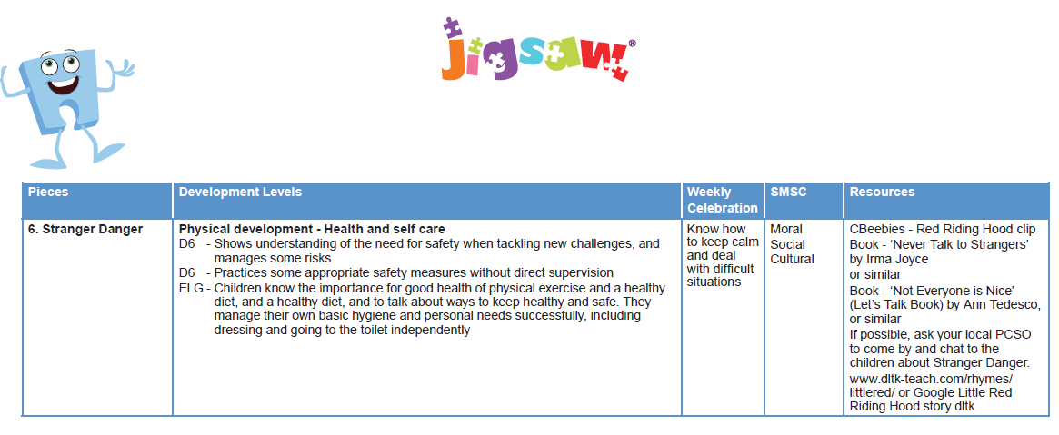

Year 1 Puzzle Map
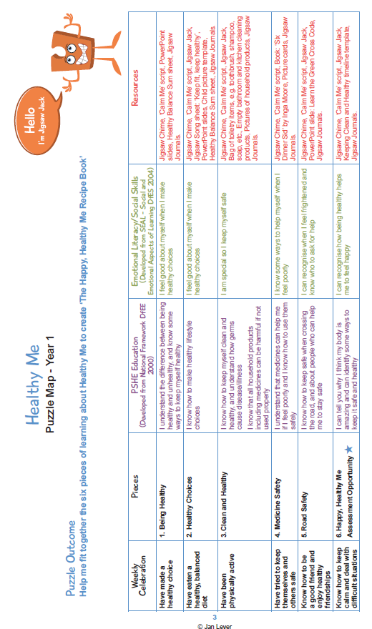

Year 1: Suggested Vocabulary
- Healthy, unhealthy, balanced, exercise, sleep
- Healthy, unhealthy, balanced, exercise, sleep, choices
- Healthy, clean, body parts, toiletry items (e.g. toothbrush, shampoo, soap), hygienic, safe
- Medicines, healthy, unhealthy, trust, safe
- Safe, safety, green cross code, eyes, ears, look, listen, wait
- Keeping clean, healthy, chapter

Year 2 Puzzle Map
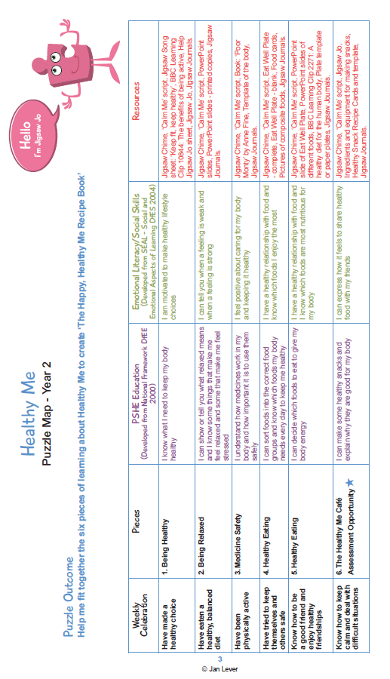

Year 2: Suggested Vocabulary
- Healthy choices, lifestyle, motivation
- Relax, relaxation, tense, calm
- Healthy, unhealthy, dangerous, medicines, safe, body
- Healthy, unhealthy, balanced diet, portion, proportion
- Healthy, unhealthy, balanced diet, energy, fuel, nutritious
- Healthy, unhealthy, balanced diet, nutritious

Year 3 Puzzle Map
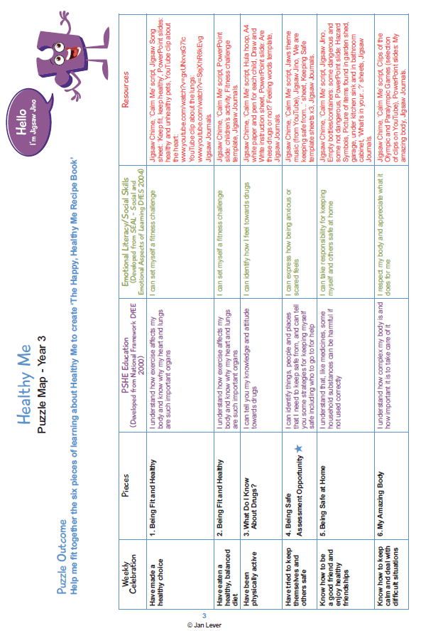

Year 3: Suggested Vocabulary
- Oxygen, heartbeat, lungs, heart, fitness
- Oxygen, heartbeat, lungs, heart, fitness, challenge
- Healthy, drugs, attitude
- Safe, anxious, scared, strategy, advice
- Safe, harmful, medicines, substances
- Complex, appreciate, body

Year 4 Puzzle Map
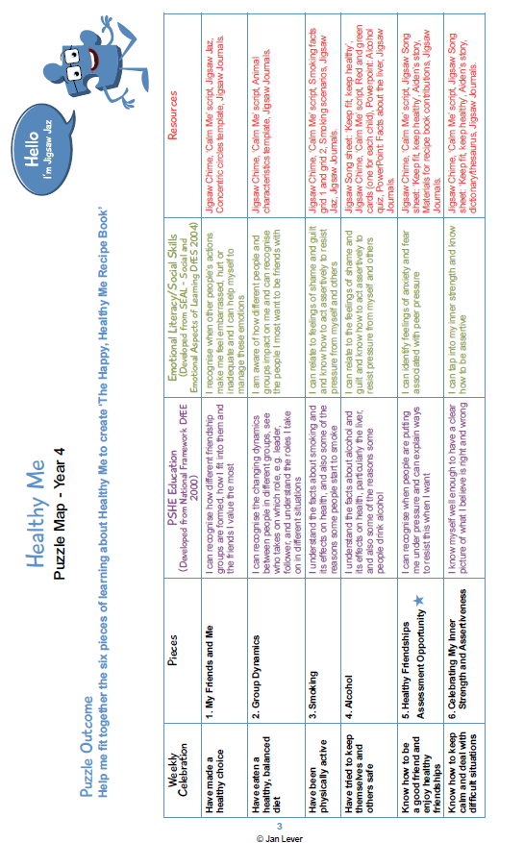

Year 4: Suggested vocabulary
- Friendships, emotions, healthy, relationships, friendship groups, value, embarrassed
- Friendship groups, roles, leader, follower, assertive, agree / disagree
- Smoking (Teacher to include the use of e-cigarettes as advised by Healthy Schools Liaison Officer):, pressure, peers, guilt, advice
- Alcohol, liver, diseased
- Pressure, peers, anxiety, fears
- Believe, opinion, assertive, right, wrong

Year 5 Puzzle Map

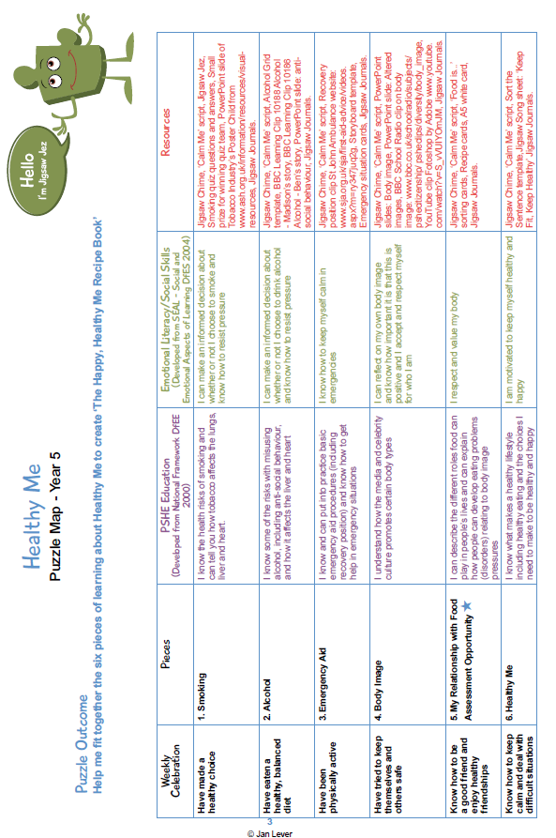

Year 5 Suggested vocabulary
- Smoking (Teacher to include the use of e-cigarettes as advised by Healthy Schools Liaison Officer): Choices, healthy behaviour, unhealthy behaviour, informed decision, pressure
- Alcohol: Choices, healthy behaviour, unhealthy behaviour, informed decision, pressure
- Emergency procedure, recovery position, calm, level-headed
- Body image, media, celebrity, altered, self-respect
- Body image, eating problem, respect, pressure
- Choices, healthy lifestyle, motivation

Year 6 Puzzle Map
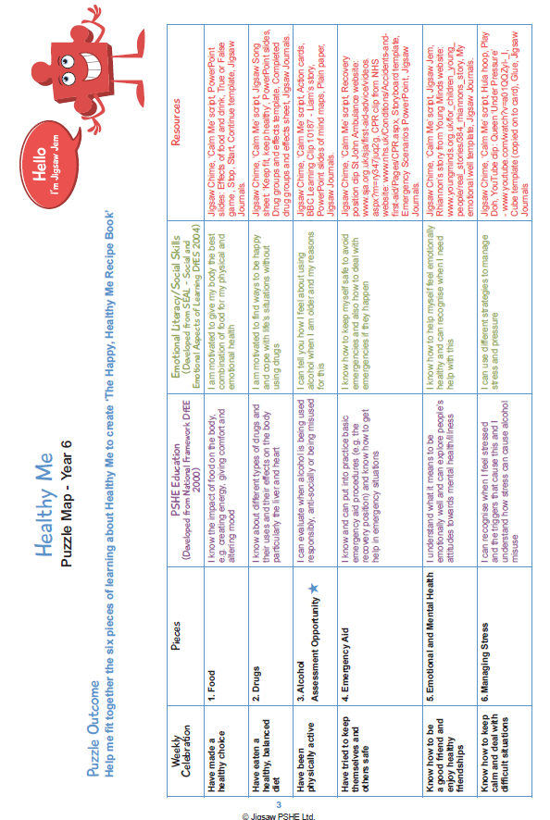
Year 6: Suggested Vocabulary
- Mood, energy, balanced diet
- Drugs, effects, motivation
- Misuse, anti-social, responsible, appropriate
- Emergency, recovery position, CPR, safety
- Mental health, emotional health, mental illness, symptoms
- Stress, triggers, strategies, managing stress, pressure

